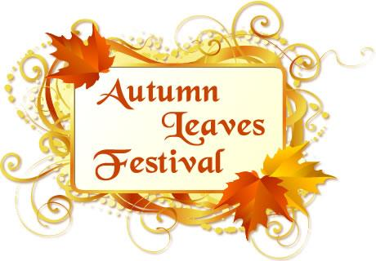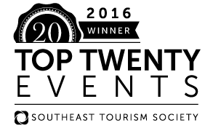

Southeast Tourism Society Selects ____Autumn Leaves Festival____ as a

‘STS Top 20 Event’

Travel industry organization has saluted region’s best events since 1985

ATLANTA, Ga. June 13, 2016 – The Southeast Tourism Society has named the Autumn Leaves Festival one of the STS Top 20 Event in the Southeast for October 2016 .

This year’s Autumn Leaves Festival is October 14-16, 2016 . The STS Top 20 Festival and Event Awards have highlighted programs around the Southeast since 1985.
Travel industry experts select 20 events per month, and STS publicizes them throughout the United States. The complete list is published on two websites: EscapeToTheSoutheast.com and Travel Media Press Room.
The Autumn Leaves Festival is one of the most successful and sought after events in the Southeast. This year it will be celebrating its 50th year.
“The Southeast Tourism Society’s Top 20 Festival and Event list is an excellent guide for the Southeast’s visitors and residents. Events selected represent the best, and often most unique, activities in our region,” said Bill Hardman, president and CEO of the Southeast Tourism Society.

Events considered for the STS Top 20 recognition must be at least three years old and have attendance of at least 1,000.

STS, founded in 1983 and headquartered in Atlanta, Ga., is a non-profit organization dedicated to promoting tourism to and within 12 states – Alabama, Arkansas, Florida, Georgia, Kentucky, Louisiana, Mississippi, North Carolina, South Carolina, Tennessee, Virginia and West Virginia.
#
Contact:
Yvonne Nichols
yvonne@mtairyncchamber.org
336-786-6116

